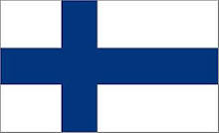
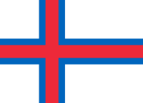
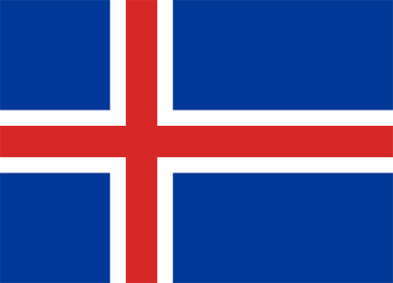
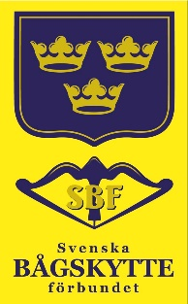
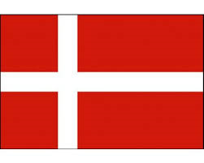
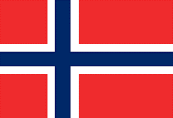
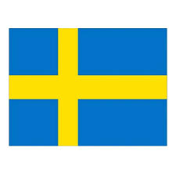
Swedish junior national team invites to

Landslagskampen no.1

7 mars 2021

Online competition between the junior national teams in Norway, Denmark and Sweden.

Classes: RCW, RJW, RCM, RJM
CCW, CJW, CCM, CJM

Rond: indoor WA 12/18m, 2x30 pil

Time: Possible to compete from 10 am to 6 pm.

Registration: one per nation, emailed no later than 28/2
*Ianseo-id for ianseo-registration.

Location: Decided by the national team captain for each national team.

Requirement

* Shooters use the ianseo scorekeeper app.

* Each nation must notify an ianseo contact person from each country. Email the name and email address to the contact person to

* Shooting cards will be sent to the team captain, who will forward them to the shooters.

Welcome

